Assignment RSA

**Learning Objectives:**

* Explore the RSA algorithm, and write a RSA cracking program <https://brilliant.org/wiki/rsa-encryption/>
* Understand message decomposition and construction.

**Background Information Preamble**

* The RSA algorithm paper (1977):

<https://people.csail.mit.edu/rivest/Rsapaper.pdf>

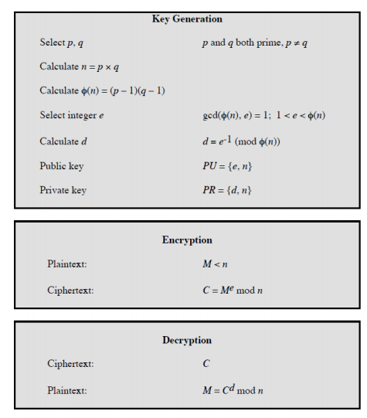

You may use the Extended Euclidian Algorithm by hand, or use something like this applet: <http://bilhamil.com/cryptoapps/ExtendedEuclideanAlgorithm.html> to help calculate your private key *d*, and check your work.

The extended Euclidean theorem tells us that for:

*ax + by = gcd(a,b)*

It can be shown that:

* “a” is 
* “b” is *e*
* “y” is *d ,* our private key.

In other words:

*x + ed = gcd(a,b) = 1*

See examples from lecture notes.

# Part 1: How hard can it be?

Cracking a RSA code (given only public key e, n) requires these steps:

1. Find 2 prime-factors, of the public key modulus.
2. Now you have p, and q; Then, calculate the totient Ø.
3. Now you have (e, Ø). So, you can use Extended Eulers or iterative method to find “d”.

Let’s have a crack at it yourself, step by step.

You can use any programming language.

1. Write a function ***isPrime(integer num)***

that returns true if “num” is prime, and false otherwise.

The algorithm involves seeing if the number is divisible by all the prime numbers less than $\sqrt{n}$

Some numbers you can test with: 779, 817, 893, 1007, 1121, 1159, 1273, 1349, 1387, 1501, 1577, 1691, 1843, 667, 713, 851, 943, 989, 1081, 1219

1. Write a function ***primeFactor(integer n)***

that takes input the integer modulus “n”,

and find all the prime-factors of that number.

This is called prime-factorization.

If there are only 2 non-zero prime-factors, we are in luck (in terms of cracking RSA!)­­­

Some numbers you can test: 923, 949, 1027, 1079, 1157, 1261, 323, 391, 493, 527, 629, 697, 731, 799, 901, 1003, 1037, 1139, 1207, 1241, 1343, 1411, 1513, 1649, 437, 551, 589, 703, 779, 817, 893

1. Now let’s suppose you are working for the “good guys”, and given: “e”, and “Ø”. Write a function ***calculatePrivateKey (integer e, integer Ø)***

that calculates “d”(the private key).

Some (e, Ø) pairs you can test with: (131, 328), (79, 328), (23, 84),

(113, 576), (157, 168), (37, 84), (277, 576), (499, 576)

1. Finally, using the functions you have already done, create a program that takes 2 input parameters, “e”, and “n”.

***rsacrack {e} {n}***

***Usage example: rsacrack 3 187***

You input the public key (e, and n), and it provides a private key “d” (ie, crack the code, using brute force!)

(FYI: By 1996, 40-bit keys could be cracked in about 4 hours by a cluster of workstations)

Some (e, n) pairs you can test with: (131, 415), (79, 415), (37, 129),

(23, 129), (113, 679), (157, 215), (277, 679), (499, 679)

Provide bash (or make file) that runs with some sample inputs.

Submit zip folder.

# Part 2: Encrypt and Decrypt a Message

You want to send the password “LOL” (three 8-bit asci characters) to your BTech friend, whose public key is (7,187). Since the modulus is 187, use 7 bits for your message blocks. Show work.

|  |  |
| --- | --- |
| Message encoded into bits: |  |
| Message separated into 7-bit messages: | M1 =  M2 =  M3 =  M4 = |
| Encrypt each message using public key: | C1 =  C2 =  C3 =  C4 = |
| Suppose your friend’s totient (phi) is 160, what is the private key? |  |
| Decrypt the cipher messages above to check your work: | M1=  M2=  M3=  M4= |